Pickup Info (for delivery day) | Customer Information |  |  | Bundle A |  | Bundle B | Total $ | Payment Method
 | Name | Email | Phone | $14 |  | $15 | ( $A + $B) | Cash | Cheque
Called ☐  Picked up ☐ |  |  |  | ____x$14=$_____ |  | ____x$15=$_____ | = $__________ | = $_____ | = $______
Called ☐  Picked up ☐ |  |  |  | ____x$14=$_____ |  | ____x$15=$_____ | = $__________ | = $______ | = $______
Called ☐  Picked up ☐ |  |  |  | ____x$14=$_____ |  | ____x$15=$_____ | = $__________ | = $______ | = $______
Called ☐  Picked up ☐ |  |  |  | ____x$14=$_____ |  | ____x$15=$_____ | = $__________ | = $______ | = $______
Called ☐  Picked up ☐ |  |  |  | ____x$14=$_____ |  | ____x$15=$_____ | = $__________ | = $______ | = $______
Called ☐  Picked up ☐ |  |  |  | ____x$14=$_____ |  | ____x$15=$_____ | = $__________ | = $______ | = $______
Called ☐  Picked up ☐ |  |  |  | ____x$14=$_____ |  | ____x$15=$_____ | = $__________ | = $______ | = $______
Called ☐  Picked up ☐ |  |  |  | ____x$14=$_____ |  | ____x$15=$_____ | = $__________ | = $______ | = $______
 |  |  |  |  | Total Bundle A | Total Bundle B | Grand Total  $ | Total Cash  Attached  $ | Total Cheques  Attached  $
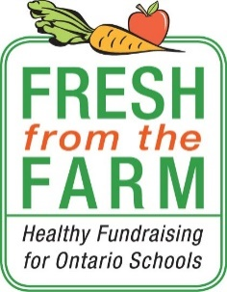
School Name: Jeanne Sauvé
Teacher: __________________________________
Student Name: ______________________________
Student Contact Info (optional): _________________
Ontario-grown $15 Greenhouse Bundle
Pre-boxed (ready-to-be-picked up)
- 1-14oz tray of mini seedless cucumbers
- 1- Pint clamshell of grape tomatoes
- 1- XL cello wrapped red pepper
- 1- XL cello wrapped orange pepper
- 1- XL cello wrapped yellow pepper

- Contributes to a healthy learning environment in schools
Student Order Form

A fresh take on
school fundraising

